Part 1 – Logical Modeling Case Studies

1. Case Study 1

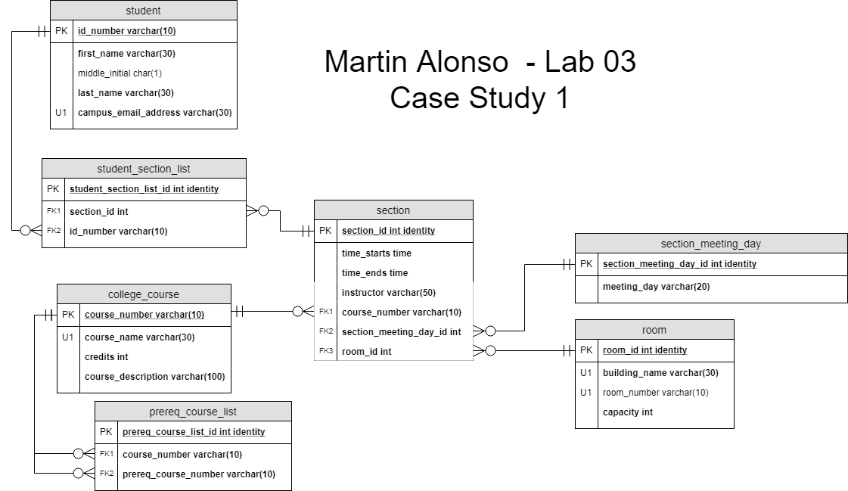

1. Case Study 2



1. Case Study 3

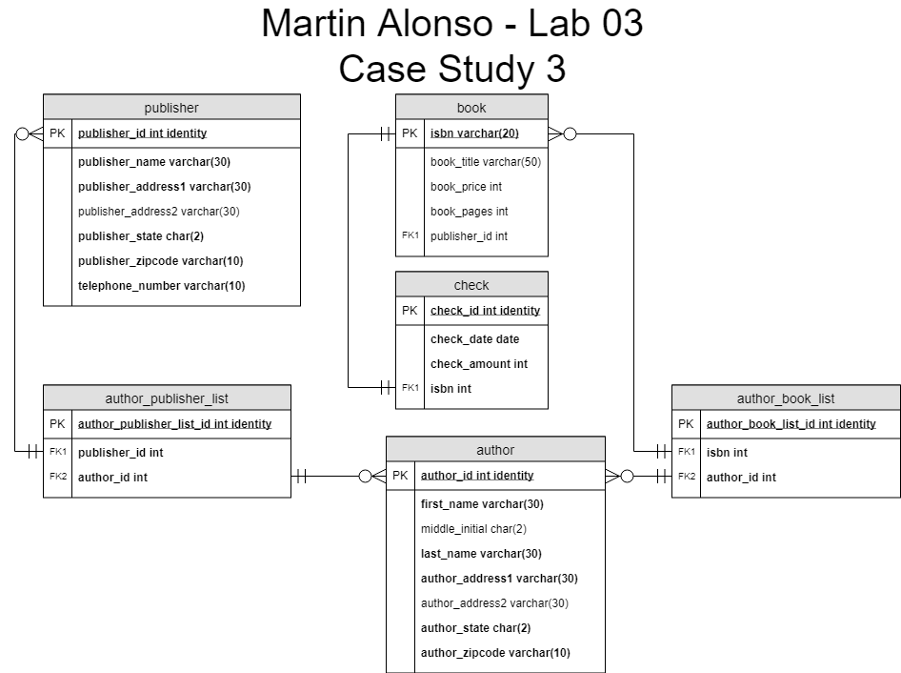

Part 2 – VidCast Logical Model

